**Subhan Bin Yousaf**

**Section B**

**481281**

**FOP Lab Manual 6**

**Lab Tasks**

Task 1 :

#include <iostream>

using namespace std;

int main() {

int a;

cout << "Enter number of terms to generate: ";

cin >> a;

int b, c, d;

b = 0;

c = 1;

cout << b << " " << c << " ";

for (int i = 2; i < a; i++) {

for (int j = 0; j < i - 1; j++) {

d = b + c;

cout << d << " ";

b = c;

c = d;

}

}

cout << endl;

return 0;

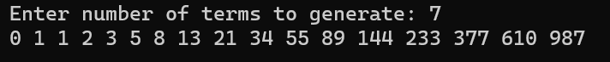}

Task 2 :

#include <iostream>

using namespace std;

int main(){

int a;

cout<<"enter number of rows: ";

cin>>a;

int b=1;

for(int i=0;i<=a;i++){

for(int j=0;j<=i;j++){

cout<<b<<" ";

b++;

}

cout<<endl;

}

return 0;

}

